DATE: 08.11.2019
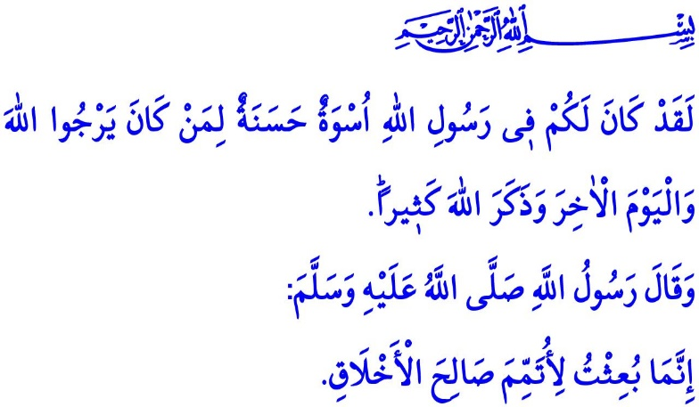
THE MAWLID AL-NABI
Honorable Muslims!
As you know, today is Friday; that is, a celebration day for Muslims. Tonight is the Night of Mawlid (Laylat al-Mawlid), the anniversary of the Prophet Muhammad (saw) honoring the world with his birth, who communicated the message of Islam to us, taught us the right and truth, and guided us as the best role model on the road to the Heaven. Endless thanks and praise be to the Almighty Allah (swt) for honoring us to be the members of the ummah of the Last Prophet Muhammad's (saw) of sublime character and sweet tongue. Salat and salam be to the Prophet Muhammad (saw), whom Allah (swt) sent as an ambassador of peace, mercy, and trust to the worlds, and to his family and his companions.
Dear Believers!
The Prophet Muhammad (saw) was an inviter who invited all people to peace and salvation, and a warner who warned all people against and saved them from wrongdoing and being rebellious. He was the perfect living answer to the questions of “What do Muslims believe?” and “What kind of a life should Muslims lead?” In him were embodied such virtues as affection, compassion, loyalty, courage, and foresightedness. By him earned the weak, the poor, and the victimized people the deserved respect for being human. Around him became guided even the people, who wanted to kill him, to the right path thanks to his compassion. So much so that a dark age dominated by ignorance and oppression and lack of compassion, virtues, and wisdom turned into the Age of Bliss (the Asr al-Saadah) under the light of knowledge, justice, and compassion with his arrival and divine struggle. People who had lost their way and values in the whirl of the Jahiliyyah (Ignorance) period set the best examples of brotherhood, virtues, commitment to promises, and all good behaviors by following his path.
Dear Muslims!
In this regard, he said, “I was sent to perfect the good moral character.” His life was filled with countless beautiful words and actions.It was him who declared that all people were equal before Allah and the criterion of superiority was piety (taqwa) by saying, “Humans are children of Adam, and Adam was created from earth.” It was him who taught his ummah to be humble by saying “Fear not; I am just a man whose mother used to eat dried meat.” to someone speaking with him in a state of excitement and shaking voice. It was again him who advised us to pursue not the temporary blessings of this world but the approval of Allah (swt) by praying to Him, “O Allah, I beseech You for guidance, piety, chastity, and contentment.”
Dear Believers!
The Almighty Allah (swt) states in the Holy Qur'an, “There has certainly been for you in the Messenger of Allah an excellent pattern for anyone whose hope is in Allah and the Last Day and [who] remembers Allah often.”
Then let us get to know the Prophet Muhammad (saw) better, understand him better, and make sure that his great Sunnah has a determining role in our lives. Let us shape our world of thought according to his mentality, and let us clean our hearts with his morals. Let us protect all the principles, on which he never made any concessions, in all domains of our lives. Let us not forget that our faith, our humanity, and our society will reach the long-awaited good days to the extent that we take him as our role model. Only then will his birth (mawlid) mean literally a rebirth in our lives.
Honorable Muslims!
As in every year, the week following the Night of Mawlid will be celebrated as the Mawlid al-Nabi Week this year as well. The theme of the Mawlid al-Nabi Week 2019 is set to be “the Prophet Muhammad and the Family” by the Presidency of Religious Affairs. This is because it is our family values that are damaged worst in this world where peace is lost in the whirl of selfishness and self-interests and love is gone due to material concerns. It is therefore a duty upon all of us to ensure that families are established, protected, and maintained properly.
As in all matters, our best role model in the matter of family is also the Prophet Muhammad (saw). During the Mawlid al-Nabi Week, various events will be organized to introduce to our society the environment of love, compassion, trust, peace, and consultation within the family of the Prophet Muhammad (saw), and solutions will be sought, in line with the Holy Qur'an and the Sunnah, for today's problems faced by the institution of family.
I would like to take this opportunity to congratulate you all for the Night of Mawlid, and pray to Allah the Almighty (swt) that the Week may bring good things to our noble nation and the Muslim world.

(Ibn Hanbal, II, 381)
(Tirmidhi, Manaqib, 74)
(Ibn Majah, At'imah, 30)
(Muslim, Dhikr, 72)
Ahzab, 33/21. General Directorate of Religious Services

